 **OUTREACH SCHOOLS EXAMINATIONS BOARD**

**MID TERM I EXAMINATION 2023**

**PRIMARY TWO**

**MATHEMATICS**

**Name: ___________________________________________**

**School: ____________________________________________**

**SECTION A**

1. **Add correctly.**

a) 3+4+6 =

b) 8

+4__

_______

c) 2 6

+1 2_

_________

1. **Draw these sets.**
2. A set of three trees.
3. A set of two cats.
4. 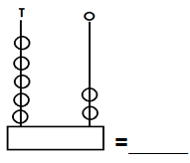**Count the beads and write the number.**

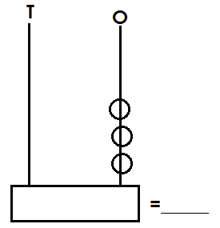

1. b)
2. **Write the number**.
3. 8 tens 4 ones = ___________
4. 7 tens = ___________
5. 3 ones = ___________
6. **Circle the greater number.**
7. 9 and 4
8. 61 and 16
9. 23 and 14
10. **Name the shapes.**
11. b)

**___________________ ___________________**

**(oval, rectangle, circle)**

1. 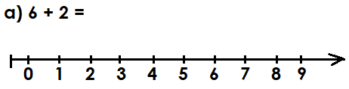**Add using a number line.**

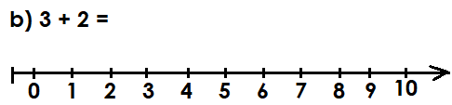

**SECTION B**

1. **Match correctly.**

forty 8

thirty two 40

eight 32

1. 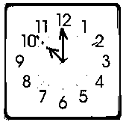**Tell the time.**

It is ______________o’clock.

1. 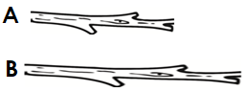**Use “longer” or “shorter”**
2. Stick B is ____________________ than stick A.
3. Stick A is___________________ than stick B.
4. **Tables / Times.**
5. 3 x 2 = _____
6. 2 x 0 = _____

1. 8

x 2__

_______

1. 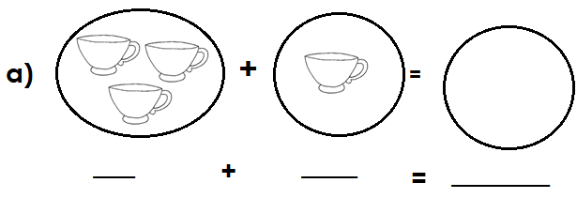**Add the sets.**

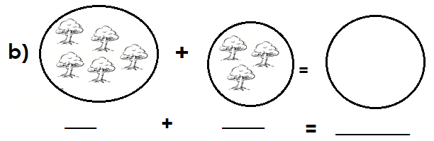

1. **Draw tens and ones.**
2. 14 = ___________________________
3. 20 = ____________________________
4. **Write the number before.**
5. ______, 9
6. ______, 10
7. ______, 14
8. **Write in figures.**
9. twenty = _______
10. sixteen =_______
11. four =_________
12. **Fill in the missing numbers.**
13. 14, 15, ______, ______ 18, 19.
14. 0, 2, 4, _______, ______ 10, 12.
15. **Read, understand and show the working.**
16. Three boys have ______________ eyes.
17. Six plus two equals __________________
18. Two groups of three give ________________
19. Nine minus three equals ________________
20. How many legs do you have? _________________________________
21. How many days make a week?_________________________________
22. A cow has __________ legs.

**“Good Luck”**